REAL TIME IMAGE BASED SMART VOTING SYSTEM

## A MINI PROJECT-I REPORT

***Submitted by***

|  |  |
| --- | --- |
| **SIVAMURUGAN G** | **621321106098** |
| **TAMILSELVAN S** | **621321106109** |
| **VETRIVEL K** | **621321106115** |

***in partial fulfillment for the award of the degree of***

# BACHELOR OF ENGINEERING

***in***

## ELECTRONICS AND COMMUNICATION ENGINEERING

**KONGUNADU COLLEGE OF ENGINEERING AND TECHNOLOGY (AUTONOMOUS)**

# ANNA UNIVERSITY :: CHENNAI 600 025

**NOVEMBER 2023**

## KONGUNADU COLLEGE OF ENGINEERING AND TECHNOLOGY

**(AUTONOMOUS)**

# ANNA UNIVERSITY :: CHENNAI 600 025 BONAFIDE CERTIFICATE

Certified that this Project Report **“REAL TIME IMAGE BASED SMART VOTING SYSTEM”** is the bonafide work of **“SIVAMURUGAN G (621321106098), TAMILSELVAN S (621321106109)**

**and VETRIVEL K (621321106115)”** who carried out the 20EC506L Mini Project-I workunder my supervision.

## SIGNATURE SIGNATURE

Dr.M.DHARMALINGAM, M.E., Ph.D., Dr.B.UMARANI, M.E., Ph.D.,

|  |  |
| --- | --- |
| **HEAD OF THE DEPARTMENT**  Professor ,  Department of Electronics and Communication Engineering , Kongunadu College of Engineering and Technology (Autonomous),  Thottiam, Trichy-621 215 | **SUPERVISOR**  Professor,  Department of Electronics and Communication Engineering , Kongunadu College of Engineering and Technology (Autonomous),  Thottiam, Trichy-621 215 |

Submitted for the project viva-voce examination held on

## INTERNAL EXAMINER EXTERNAL EXAMINER

**KONGUNADU COLLEGE OF ENGINEERING AND TECHNOLOGY**

## (AUTONOMOUS)

**Namakkal-Trichy Main Road, Tholurpatti, Thottiam- Taluk, Trichy- Dist,**

**Tamil Nadu -621 215**

## COLLEGE VISION & MISSION STATEMENT

**VISION**

“To become an Internationally Renowned Institution in Technical Education, Research and Development, by transforming the Students into Competent Professionals with Leadership Skills and Ethical Values”

## MISSION

* Providing the Best Resources and Infrastructure
* Creating Learner - Centric Environment and continuous Learning
* Promoting Effective Links with Intellectuals and Industries
* Enriching Employability and Entrepreneurial Skills
* Adapting to Changes for Sustainable Development

## KONGUNADU COLLEGE OF ENGINEERING AND TECHNOLOGY (AUTONOMOUS)

**Namakkal-Trichy Main Road, Tholurpatti, Thottiam- Taluk, Trichy- Dist, Tamil Nadu -621 215**

**DEPARTMENT OF ELECTRONICS AND COMMUNICATION ENGINEERING**

## VISION

To create highly skilled, proficient and excellent Electronics and Communication Engineers having professional ethics, passion and competence to adapt to the latest transformations in technology.

## MISSION

* + Promoting quality teaching and effective learning to face the global challenges
  + Enriching professionals of high caliber to excel in their careers through students’ overall development
  + Promoting education that imparts multidisciplinary design approaches, innovation and creativity

## PROGRAM EDUCATIONAL OBJECTIVES (PEOs)

**PEO1**: Graduates shall exhibit the skills and knowledge required to design, develop and implement solutions for real life problems.

**PEO2**: Graduates shall excel in professional career, higher education and research.

**PEO3**: Graduates shall demonstrate professionalism, entrepreneurship, ethical behaviour, communication skills and collaborative team work to adapt the emerging trends by engaging in lifelong learning.

## PROGRAM SPECIFIC OUTCOMES (PSOs)

**PSO1:** Students shall have skills and knowledge to work and design on PCB, analog and digital systems, adhoc and sensor networks, embedded and communication systems.

**PSO2:** Students are able to perform and design in the simulation tools and

IoT related modules.

# PROGRAM OUTCOMES (POs)

1. **Engineering knowledge**: Apply the knowledge of mathematics, science, engineering fundamentals, and an engineering specialization to the solution of complex engineering problems.
2. **Problem analysis**: Identify, formulate, review research literature, and analyze complex engineering problems reaching substantiated conclusions using first principles of mathematics, natural sciences, and engineering sciences.
3. **Design/development of solutions**: Design solutions for complex engineering problems and design system components or processes that meet the specified needs with appropriate consideration for the public health and safety, and the cultural, societal, and environmental considerations.
4. **Conduct investigations of complex problems**: Use research-based knowledge and research methods including design of experiments, analysis and interpretation of data, and synthesis of the information to provide valid conclusions.
5. **Modern tool usage**: Create, select, and apply appropriate techniques, resources, and modern engineering and IT tools including prediction and modeling to complex engineering activities with an understanding of the limitations.
6. **The engineer and society**: Apply reasoning informed by the contextual knowledge to assess societal, health, safety, legal and cultural issues and the consequent responsibilities relevant to the professional engineering practice.
7. **Environment and sustainability**: Understand the impact of the

professional engineering solutions in societal and environmental contexts, and demonstrate the knowledge of, and need for sustainable development.

1. **Ethics**: Apply ethical principles and commit to professional ethics and responsibilities and norms of the engineering practice.
2. **Individual and team work**: Function effectively as an individual, and as a member or leader in diverse teams, and in multidisciplinary settings.
3. **Communication**: Communicate effectively on complex engineering activities with the engineering community and with society at large, such as, being able to comprehend and write effective reports and design documentation, make effective presentations, and give and receive clear instructions.
4. **Project management and finance:** Demonstrate knowledge and understanding of the engineering and management principles and apply these to one’s own work, as a member and leader in a team, to manage projects and in multidisciplinary environments.
5. **Life-long learning**: Recognize the need for, and have the preparation and ability to engage in independent and life-long learning in the broadest context of technological change.

## ABSTRACT

The cheating voter is a pressing issue in electoral systems globally, encompassing various illicit activities that undermine the integrity of elections. Instances of multiple voting, impersonation, fraudulent registrations, and ballot tampering erode public trust in the democratic process, potentially skewing election outcomes unfairly. This multifaceted problem poses challenges related to resource allocation, legal and ethical dilemmas, and the erosion of fair representation. Addressing voter fraud requires a balanced approach that includes secure voter registration, advanced technology, voter education, and stringent penalities to maintain the integrity of election and restore confidence in the democratic system. This novel method does rid of the possibility of fraudulent voting by taking voters' fingerprints or face scans and evaluating them in real time. Furthermore, remote voting is made possible by smart voting technologies, enabling voters to cast ballots from the comfort of their homes or other pre-designated locations. Elections that are inclusive and transparent are facilitated by the use of real-time image analysis, which guarantees the legitimacy of remote votes. Furthermore, the system's instantaneous results speed up the announcement of election results and reduce human error by streamlining the vote-tallying process.

## ACKNOWLEDGEMENT

The satisfaction that ones on completing a project cannot be fully enjoyed without mentioning the people who made it possible. We express our sincere thanks and our grateful acknowledgement to our chairman **Dr.PSK.R.PERIASWAMY**, Kongunadu Educational Institutions for providing ample facilities in the college for undertaking our project.

We wish to express our gratitude and thanks to our beloved Principal **Dr. R. ASOKAN, M.S.,M.Tech.,Ph.D.,** for forwarding us to do our project and offering adequate duration in completing our project.

We would like to thank **Dr.J.YOGAPRIYA, M.E.,Ph.D.,** Dean(R&D) Kongunadu college of Engineering and Technology for her encouragement during the course of study.

We have immense pleasure in expressing my sincere gratitude toour Head of the Department **Dr.M.DHARMALINGAM, M.E.,Ph.D.,** and my project supervisor **Dr.B.UMARANI, M.E.,Ph.D.,** for their meticulous guidance which was an inspiration to us.

We also express our gratefulness to my **PARENTS** and my **FRIENDS** for their affectionate blessings and loving co-operation at all stages of this academic venture.

## TABLE OF CONTENTS

|  |  |  |  |  |
| --- | --- | --- | --- | --- |
| **CHAPTER NO.** |  |  | **TITLE** | **PAGE NO.** |
|  | **ABSTRACT** | | | **Vii** |
|  | **LIST OF FIGURES** | | | **Xi** |
| **1** | **INTRODUCTION** | | | **1** |
|  | 1.1 | GENERAL | | 1 |
|  | 1.2 | OBJECTIVE | | 2 |
|  | 1.3 | IMPLEMENTATION | | 3 |
|  | 1.4 | MOTIVATION | | 3 |
| **2** | **LITERATURE REVIEW** | | | **5** |
| **3** | **EXISTING SYSTEM** | | | **11** |
|  | 3.1 | INTRODUCTION | | 11 |
|  | 3.2 | BLOCK DIAGRAM | | 12 |
|  | 3.3 | EXPLANATION | | 12 |
|  |  | 3.3.1 | Control Unit | 12 |
|  |  | 3.3.2 | VVPAT | 13 |
|  |  | 3.3.3 | Button Unit | 13 |
|  |  | 3.3.4 | Display Unit | 14 |
| **4** | **PROPOSED SYSTEM** | | | **15** |
|  | 4.1 | INTRODUCTION | | 15 |
|  | 4.2 | BLOCK DIAGRAM | | 15 |
|  |  | 4.2.1 | User Barcode Voter ID | 16 |

|  |  |  |  |  |
| --- | --- | --- | --- | --- |
|  |  | 4.2.2 | Scan the Voter Id | 16 |
|  |  | 4.2.3 | Verification | 16 |
|  |  | 4.2.4 | Permission to Vote | 17 |
|  |  | 4.2.5 | Display Information | 17 |
|  | 4.3 | EXPLANATION | | 18 |
|  | 4.4 | FLOW CHART | | 19 |
| **5** | **SOFTWARE DESCRIPTION** | | | **20** |
|  | 5.1 | PYTHON PROGRAMMING | | 20 |
|  | 5.2 | SOFTWRE IMPLEMENTATION | | 21 |
| **6** | **RESULT AND DISCUSSINON** | | | **23** |
|  | 6.1 | APPLICATION DASHBOARD | | 23 |
| **7** | **ADVANTAGES AND APPLICATIONS** | | | **30** |
|  | 7.1 | ADVANTAGES | | 30 |
|  | 7.2 | APPLICATIONS | | 30 |
| **8** | **CONCLUSION** | | | **31** |
|  | **APPENDX** | |  | **32** |
|  | **REFFERENCES** | | | **35** |

**LIST OF FIGURES**

|  |  |  |
| --- | --- | --- |
| **FIGURE NO.** | **DESCRIPTION** | **PAGE NO.** |
| 3.1 | Existing Block Diagram | 12 |
| 4.1 | Proposed Block Diagram | 15 |
| 4.2 | Flow Chart | 19 |
| 6.1 | Voter Application | 23 |
| 6.2 | Camera Access | 24 |
| 6.3 | Authenticated User | 25 |
| 6.4 | Unauthenticated User | 26 |
| 6.5 | Voted Members List | 27 |
| 6.6 | Voters List Saved in Work Sheet | 28 |

## CHAPTER 1 INTRODUCTION

* 1. **GENERAL**

The image based voting system is a software application that can control the voter fraud and cheating in voting during the voter posted his/her vote in our election time. When using the image based voting system, we cannot go to any booth for voting simply opened app and register our face and select our vote. Therefore the image based voting can help the government and common people for voted in an easy way and increase the accuracy of voting. It is necessary to safe our voter card because it is our main proof for voting and acknowledgement to our self. For the image based voting system it is not necessary to open the application in the specific location. we can use the image based voting system in any place during the election time. This image based voting system is used to easily count our vote and provide the exact result for the election.

The image based voting system we can use the python programing for capture our image and specific code in our id. Ensure the only eligible voters participate by using biometric data or facial recognition to verify their identity in real-time. Increase transparency in the election process by recording and storing images and data of each vote cast, making it possible for audits and recounts. Speed up the voting process and reduce waiting times at polling stations through streamlined, technology-driven procedures.

## OBJECTIVE

This project make voting more accessible to a wider range of voters, including those with disabilities, by providing user-friendly interfaces and options for remote voting. Allow voters to cast their votes from various locations, reducing the need for physical presence at polling stations and increasing participation. Provide instant or near-instantaneous results, offering a faster and more accurate outcome of the election. Minimize human errors in vote counting and data entry. Potentially reduce the costs asated with traditional paper-based voting systems.

Furthermore, the method takes accessibility issues into account by allowing voters who are far away or have special needs. It encourages inclusivity in the democratic landscape by allowing citizens to take part in the election process from the comfort of their homes through safe and user-friendly interfaces. Using state-of-the-art technology simplifies the voting process overall while also lowering the possibility of human error. As the system makes voting easier and more convenient, long lines and wait times become obsolete.This intelligent voting system aims to transform the electoral landscape by combining accessibility features, real- time processing, and image-based authentication. In terms of safeguarding election integrity, promoting public confidence, and building a more functional and approachable democratic framework for citizens, it is a technological advance.

## IMPLEMENTATION

In recent years, most of the artificial applications are designed to be controlled remotely via internet to make the access to the machines from anywhere over the world is easier. Plan the system architecture, including hardware and software components, databases, and interfaces. Ensure that the system can handle real-time data processing and is scalable to accommodate a large number of voters.

Implement a robust authentication system, which may include biometric verification (e.g., facial recognition, fingerprint scanning) to ensure that only eligible voters can participate. Create a voter registration database to store voter information and validate eligibility. Ensure data privacy and security measures are in place. Implement strong encryption to protect voter data and ensure its security during transmission and storage. Therefore the serious effort designing and implementing suitable program for image based voting are spend.

## MOTIVATION

In olden days, opportunity on software in election time is very less but few years later the government can introduce the new button system, this system having lot of drawbacks. During this time we can use the image based voting system to easily posted our votes and secure our voters data from external sources. Streamline the voting process to reduce waiting times at polling stations and speed up the overall process, resulting in a more efficient and convenient experience for voters. Reduce the environment impact of traditional paper based voting systems by minimizing paper usage and waste. Build trust in the election process by

adopting advanced, secure, and transparent voting methods, increase public participation and satisfaction with the democratic system. Allow a citizen to vote remotely, which is especially relevant during crises, such as the COVID-19 pandemic, when physically polling stations may pose health risks. India's elections are very expensive, thus the average person might not be able to purchase them.

The only persons eligible to run for office are the wealthy. They also make illicit use of money and political influence. However, election laws ought to address the mishandling of official apparatus throughout election season. But in order to further their interests, the ruling party also employs employees and government cars. Once more, the majority of votes are being cast based on prejudice and religion. People become divided into factions as a result, which is bad for the voting system. As a result, an online voting method is suggested in order to resolve this dispute.

The desire for increased transparency and accuracy in election results is also a driving force. Instantaneous reporting of results and timely verification of voter data are made possible by real-time processing capabilities, which reduce the possibility of manipulation and boost public trust in the electoral process. In addition, the system aims to increase accessibility by meeting the various needs of voters. Through secure image-based verification, persons with disabilities and those living in remote areas can engage in democratic processes more easily, promoting inclusivity.

## CHAPTER 2

**LITERATURE REVIEW**

## V.Anitha, Orlando Juan Marquez Caro, R. Sudharsan, S. Yoganandan, M. Vimal. ‘Transparent voting system using blockchain Symmetry*’* 2020, vol. 12 Issue no*.* 8

With the use of blockchain technology, this paper aims to develop a decentralized transparent voting and analysis system that can be used in nations where traditional physical voting with gameable securities is practiced, raising the possibility of rigged elections. This approach will be efficient, highly secure, and justifiable. This system's design prioritizes a safe voting process, reduced expenses, quicker wait times, and no inequalities because of geographic independence, high scalability, and multiple false proxies. In general, a successful election mechanism to support and enhance democracy. Voters can cast ballots using the planned App from the convenience of their own residences, saving time and cutting down on the quantity of forged ballots cast. In conclusion, the real-time image-based smart voting system represents a promising and transformative approach to modernizing the electoral process. By incorporating biometric authentication, real-time image capture, and digital technology, this system aims to enhance security, accessibility, transparency, and efficiency in elections. It provides a means to address many of the challenges associated with traditional paper- based voting methods. The motivation behind this system is driven by the need to secure the integrity of the voting process, make voting more accessible, and streamline the overall experience for voters. The potential benefits include increased transparency, faster results, reduced errors.

## Alrebi, Norah, Alabdulatif, Abdulatif, Iwendi, Celestine, Lian, and Zhuotao, (2022). ‘Svbe: searchable and verifiable blockchain-based

**electronic medical records system’, Scientific Reports, Vol.12, Issue.1, pp.1–11**.

Since December 2019, the COVID-19 pandemic has been impacting people worldwide, and the number of cases is currently rising quickly. A clinical adjunct that can be utilized to diagnose COVID-19 disease is a chest X-ray imaging. Due to the quick global spread of COVID-19 and the scarcity of knowledgeable Instead of using a manual diagnosis approach, the suggested solution employs an automatic diagnosis method for radiologists. The report includes normal/pneumonia (2313) and COVID-19 Positive/Negative (2275 Positive, 4626 Negative). Chest X-ray pictures are used to diagnose conditions (Normal, 2313 Pneumonia).

## Alvi, Sy ada Tasmia, Uddin, Mohammed Nasir, Islam and Linta, (2020)‘Digital voting: Ablockchain-based e-voting system using bio hash and smart contract’, third International Conference on Smart Systems and Inventive Technology (ICSSIT), pp.228–233.

One essential democratic function is voting. Paper voting, in the opinion of many experts, is the only appropriate way to guarantee everyone's right to vote. However, this approach is prone to misuse and mistakes. Many countries use digital voting techniques to address the challenges associated with paper balloting. One imperfection in digital Voting could result in widespread vote tampering. Election voting procedures need to be accurate, safe, lawful, and consistent. convent. However, acceptability might be limited by problems with digital voting techniques. Since it is end-to-end verified, specification capacities.

## Baujard, Antoinette, Gavrel, Fr´ed´eric, Igersheim, Herrade, Laslier, Jean-François, Lebon and Isabelle(2014), “Who’s favored by evaluative voting?“ An experiment conducted during the 2012 French presidential election. Elect. pp. 131–145.

Data from a survey conducted before to the 2016 US presidential election are presented in this report. In addition to being asked about their opinions of the candidates, participants were also asked to vote using three different voting procedures: approval voting, range voting, and instant runoff voting. The participants were divided into two groups: one group faced Clinton, Trump, Johnson, and Stein, while the other group faced nine candidates—Sanders, Cruz, McMullin, Bloomberg, and Castle in addition to the first four.

## Pedro Silva, Eduardo Luz, Guilherme Silva, Gladston Moreira, Rodrigo Silva, Diego Lucio and David Menotti. COVID-19 detection in CT images with deep learning: A voting-based scheme and cross-datasets analysis [Volume 20](https://www.sciencedirect.com/journal/informatics-in-medicine-unlocked/vol/20/suppl/C), 2020.pp. 100-427

Controlling the spread of COVID-19 requires early diagnosis and detection. Recently, a variety of deep learning-based techniques have been put out to automate and aid in the diagnosis of COVID-19 screening in CT images. However, these methods have at least one of the following issues: Two things happen: (i) they handle every CT scan slice separately; and (ii) sets of pictures from the same dataset are used to train and evaluate the techniques. When the slices are treated independently, it is possible for the same patient to show up in both the training and test sets at the same time, which could lead to inaccurate results. It also begs the question of whether or not to assess the scans from the same patient together.

## Warish Patel, Monal Patel, Bhupendra Ramani. ‘Online Voting System Security based on Cryptography’ [ICACT – 2021 Vol. 09 – Issue](https://www.ijert.org/icact-2021-volume-09-issue-08) [no.08](https://www.ijert.org/icact-2021-volume-09-issue-08)

There are online voting systems, ranging from the time required to the state of technological advancement. This paper provided clarification on that. Create voting plans so that ICT resources can be used to provide more effective voting services than can be provided by traditional paper-based voting techniques. Voters view themselves as consumers, and they anticipate increased convenience in the voting process from the government. Over the last ten years, there has been a lot of interest in different electronic voting systems, particularly as extra ways to vote for voters who live far away, political parties, candidates, the electoral administration, and most importantly, to increase the effectiveness and promise of the democratic process for the general public.

## Umid Akhmedjanov, Eunjeong Ko, Eun Yi Kim.’Image Battle System’ ‘Collecting more trustable ground truth for Affect-based image indexing system’ 2013, Vol.no. 25 ,Pp. 571 – 579.

Affect-based picture indexing by visual attributes has become a significant topic of research in recent years, highlighting the significance of affective computing. In order to index photographs using effects and objects, numerous algorithms and methods have been created to date; nevertheless, the accuracy of the training data used to label the images greatly influences the algorithms' effectiveness. In order to get more reliable ground truth, the majority of the systems in use now create it by manual human tagging, which is expensive and time-consuming. Three modules make up the Image Battle

system: image rating, image voting, and image crawling. The photos are initially crawled for a text query, after which they are filtered to get rid of certain noisy data. In phase two, a pair of photographs are chosen at random from the database and assessed by participant voting. Following multiple iterations over a span of two or three months.

## Gautam, Mehul, Akthar, Shoaib, Basha, Aktar, Dilip and Golda, (2021)‘Blockchain for secure and proper management of medical data and records’ International Conference on Electronics, Communication an Aerospace Technology . pp.671–678.

To create, put into practice, and evaluate a cutting-edge audience response system (ARS) that enables image-based engagement for radiology instruction. Methods: Standard Personal Digital Assistants serve as the foundation for the ARS created for this project. (PDAs) using Microsoft® Windows Mobile® 6 Classic operating on an HP iPAQ 114 classic portable 3.5-inch TFT touch screen with integrated IEEE, high brightness, and 320 x 240 pixel resolution 802.11 wireless (b/g). Microsoft Visual Studio 2008 Professional is used for software development. was employed, and C# was used to write each component. Two technical test sessions were held for the program, and then two actual exams taken in a radiology course for thoracic radiology students pursuing medical degrees.

## Dominique Cansell,J Paul Gibson, Dominique Mery, ‘A Constructive Approach to Formal Software Design for a Secure e-voting Interface’ 2007,[Vol no. 183](https://www.sciencedirect.com/journal/electronic-notes-in-theoretical-computer-science/vol/183/suppl/C), Pp 39-55

The requirements for electronic voting machines are complicated. When it comes to the engineering of important systems, these devices ought

to be created using best practices. The accuracy and security of these systems are vital because a vulnerable system may be attacked, which could result in an election producing a false positive or producing no results at all. In the worst instance, an inaccurate result is returned without detection, possibly as a result of malicious intent. We present the application of formal technique B in ensuring basic safety properties of the voting interface of a voting machine implementing a typical version of the single transferable vote (STV) election process, and we show that an improper interface is a significant security risk.

## Jafar, Uzma, Aziz, Mohd Juzaiddin Ab, Shukur and Zarina (2021). ‘Blockchain for electronic voting system review and open research

**challenges’ Sensors, Vol.21, Issue.17, pp. 58-74.**

We have developed a new general probabilistic model on the regional voting (known as "direct popular voting" in political science) and the national voting (usually the electoral college), where we regard the percentage of a candidate's supporters in the nation as the probability of a voter voting for the candidate. This model eliminates the previous restrictive weak average distribution assumption on region sizes. According to our analysis, regional voting is consistently more stable than national voting, and the stability margin of regional voting rises as the size of these divided regions shrink that is, until a critical region size value is reached, after which the stability margin begins to fall.

## CHAPTER 3 EXISTING SYSTEM

* 1. **INTRODUCTION**

The world's voting systems currently in use vary greatly from one another, with many nations and areas implementing systems that suit their unique requirements and customs. The most popular techniques are voting on paper, voting electronically, and using a combination of the two. Voters record their selections on paper ballots in conventional paper- based systems, which are subsequently manually counted by election authorities. Although this system is renowned for its transparency and simplicity, it can be time-consuming and subject to problems like fraud and errors. On the other hand, electronic voting systems make use of technology to enable voters to cast ballots electronically through remote online voting or through computerized voting equipment at polling places. While these methods provide benefits including expedited results, enhanced accessibility, and fewer errors, they also give rise to worries over voter verification and cyber security. In order to reconcile tradition and modernity, some nations use a hybrid voting system that combines paper and technological technologies. Election integrity and voter privacy protection are of utmost importance, no matter which approach is employed. Election authorities are in charge of making sure that voting procedures are transparent and equitable, that eligible voters are registered, and that voting systems are safe. A country's technology infrastructure, cultural preferences, and the requirement to accommodate people with disabilities are some of the elements that influence the choice of voting method. Voting technology is always being discussed and developed with the goal of improving election.

## BLOCKDIAGRAM

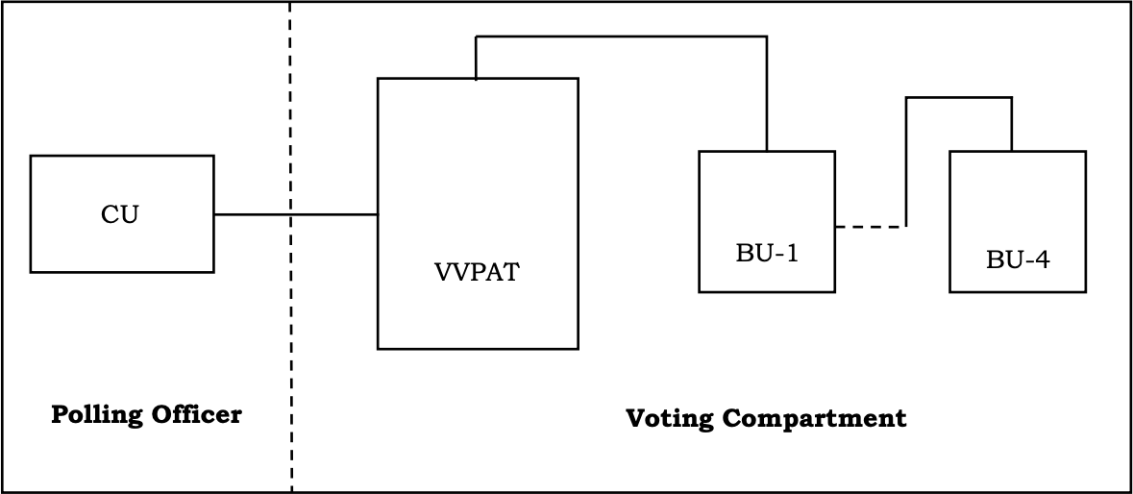

**Input**

Display Unit

**Figure 3.1 Existing Block Diagram**

## EXPLANATION

* + 1. **Control Unit (CU)**

A voting system's Control Unit (CU) is a crucial part that manages and facilitates the entire election process. It acts as the main hub for organizing all of the voting processes and guarantees the election's integrity, security, and openness. The control unit's main responsibilities include displaying the ballot to voters in an easy-to-understand manner, verifying their identities, capturing and safely storing their votes, and guarding the system from hacking and illegal access. By sending the results to a central place for effective tabulation, the control unit may help to promote communication.

## VVPAT

Voter Verified Paper Audit Trai l(VVPAT), is a system used in Electronic Voting Machines (EVM) to allow voters to verify that their vote has been cast as intended. When a voter casts their vote using an EVM, the VVPAT system generates a paper slip that contains the details of the vote, including the symbol and name of the candidate voted. The printed paper slip is displayed behind a transparent window for a few seconds, allowing the voter to verify if the details match their intended choice. After verification, the paper slip is not given to the voter but is instead dropped into a sealed VVPAT box. This paper trail serves as a physical record of each vote cast. In case of any dispute or need for a recount, these paper slips can be used to cross-verify the electronic results. This adds an additional layer of transparency and trust to the election process.

## Button Unit (BU)

The term Button Unit (BU) in a smart voting system might refer to a component that allows voters to interact with the system. The button unit serves as the interface between the voter and the electronic system. It typically includes buttons, each associated with a specific candidate or option. Voters press the button corresponding to their chosen candidate or option. This input is then registered by the electronic system.

The system may provide feedback to the voter, such as a visual confirmation on a screen or an audio signal, to indicate that their vote has been recorded. Smart voting systems incorporate security measures to ensure the integrity of the voting process. This can include encryption to protect the data, and measures to prevent tampering or fraud.

The selections made by voters are recorded electronically. This data is used to generate the final results. In many cases, these systems include features for auditability. This might involve creating a digital or paper trail that can be reviewed in case of discrepancies or challenges to the results.

## Display Unit (DU)

The Display Unit (DU) in a smart voting system serves as the interface between the voter and the electronic system, providing information and feedback during the voting process. The display unit typically shows relevant information such as the names and symbols of candidates, along with their corresponding buttons or touchpoints for selection. Clear instructions are presented on the display to guide voters through the voting process. This ensures that voters understand how to cast their votes correctly. Voters make their selections using the associated input method, such as pressing buttons, touching a screen, or using other interactive elements on the display. The display unit provides immediate feedback to the voter, confirming the selection made. This feedback is essential to ensure that voters are aware of their choices and can correct any mistakes if needed. Smart voting systems often include features on the display unit to accommodate voters with special needs, such as audio instructions or interfaces for visually impaired individuals. To cater to a diverse electorate, the display unit may offer language options, allowing voters to choose their preferred language for the voting process. The display unit is designed with security in mind. It should prevent any unauthorized access, tampering, or manipulation to maintain the integrity of the voting process. The display unit is integrated with other components of the smart voting system, such as the button unit for candidate selection and the backend system for recording and tallying votes.

## CHAPTER 4 PROPOSED SYSTEM

* 1. **INTRODUCTION**

The primary method of casting and tallying votes in elections has long been the conventional paper-based voting mechanism. However, this strategy has a number of shortcomings, including the possibility for mistakes, the need for lengthy ballot counting, and the possibility of voter fraud. It is crucial to look at cutting-edge technologies to enhance the electoral process and guarantee a fair and secure voting experience for all individuals in today's increasingly digital and technologically savvy world. A cutting-edge strategy for updating the voting process is represented by the Real-Time Image-Based Smart Voting System. This method, which makes use of advanced picture recognition and biometric technologies, seeks to speed up voting, improve security, and offer results in real time, thus improving the effectiveness and accessibility of the democratic process.

## BLOCK DIAGRAM

**User Barcode-**

**VoterID**

**Scan the Voter ID**

**Verification**

**Display Information**

**Authenticated/ Unauthenticated**

**Figure 4.1 Proposed Block Diagram**

## User Barcode Voter ID

During elections, voters can cast their ballots at designated polling places called polling stations. The purpose of these stations is to make voting easier and more orderly. Polling places, which are usually found in easily accessible public areas like community centers or schools, are furnished with voting booths or machines to guarantee ballot confidentiality. Election workers with the necessary training are on hand to help voters, confirm their identities, and offer advice as needed. A polling station's main objective is to provide a safe, impartial space where eligible voters can exercise their right to vote and participate in the democratic process.

## Scan the Voter Id

Under this technique, voters show their official identification document to a special camera or scanner, which takes a picture of the document. By utilizing sophisticated image processing methods and Optical Character Recognition (OCR) technology, the system examines the taken image and retrieves pertinent text data, including the voter's name and ID number. To confirm the person's identification, this extracted data is then cross-referenced with a database of voters who have registered to vote. The voter is allowed to continue with the voting procedure when their verification is successful. The system's architecture incorporates security and privacy protections to protect voter data, and adherence to legal and regulatory frameworks is necessary to guarantee the integrity of the system.

## Verification

An image of the voter's ID is taken in real time when they show it to a specific camera or scanning gadget. Subsequently, sophisticated

image processing methods combined with Optical Character Recognition (OCR) technology are utilized to examine and retrieve relevant information from the photographed image, including the voter's name and ID number. This extracted data is then instantly verified by cross-referencing it with an extensive voter registration database. Accuracy and legality of voting participation are guaranteed by the system's real-time identity authentication capability. The voter is given access to the voting process if the verification is successful.

## Permission to Vote

The successful completion of the verification procedure in a real-time image-based smart voting system indicates that the voter ID that was presented was correctly verified against the database of registered voters that was saved. In order to ensure that the voter's identity is legitimate and that they can continue with the election process, this confirmation is an essential step. The system's ability to quickly and accurately verify a voter's eligibility to cast a ballot is demonstrated by the verification process' success. This successful verification is largely due to the incorporation of cutting-edge technologies like Optical Character Recognition (OCR).

## Display Information

The real-time image-based smart voting system would authorize the voter to proceed and cast their vote once it had successfully verified their identity. By ensuring that only legitimate and qualified voters engage in the election process, this crucial stage preserves the voting system's security and integrity. The voter can use their democratic right to choose the candidates or options of their choosing by using the voting interface or booth once verification is complete.

## EXPLANATION

A real-time image-based smart voting system that uses cutting-edge technology to reinvent how citizens engage in elections offers a significant advancement in the democratic process. This ground-breaking technology is based on the use of Electronic Voting Machines (EVMs) with sophisticated image-capture capabilities. The act of voting is radically changed by these EVMs, which also provide a number of benefits that improve the speed, accessibility, and security of the electoral process.

This approach is based on the ground-breaking idea of photographing voters as they exercise their right to vote. These photographs serve two purposes: to confirm the voter's identification and to unmistakably link their vote to their individual image. The system's effectiveness and dependability are collectively ensured by a wide range of parts and functions that support this fundamental alteration of the voting experience.

Voter registration is a crucial first step that establishes the framework for the entire political process. Eligible persons must register prior to an election; this process can be completed online or in person at designated voter registration locations. People who register to vote supply personal information, including a photo, which is maintained in a central database and forms the voter registry. This database serves as the cornerstone for all ensuing system operations. Redundancy and backup procedures are in place to guarantee the continuity of the election process even in the event of technical difficulties or unanticipated disruptions. These measures act as a backup plan to ensure that the democratic process can continue without being seriously disrupted.

## FLOW CHART



START

DISPLAY MESSAGE



IF CAMERA TRUE

?!

Yes

SCAN THE VOTER ID

ALLOWED TO VOTE

DATA STORED IN WORK SHEET

No

Yes

VOTE

?!

END

ALREADY VOTED

SMART VOTING SYSTEM

**Figure 4.2 Flow chart**

## CHAPTER 5 SOFTWARE DESCRIPTION

* 1. **PYTHON PROGRAM**

Python is a highly adaptable and well-liked programming language, praised for its simple syntax and wide range of applications in a variety of fields. Python, which Guido van Rossum created in 1991, has become incredibly popular because to its readability and ease of use, making it the perfect language for both inexperienced and seasoned programmers. Its elegant code layout promotes uniformity and clarity by organizing the code using indentation rather than intricate brackets. One of Python's distinguishing characteristics is its versatility, which allows programmers to select the procedural or object-oriented paradigm that best suits their projects. Its huge standard library, which provides a profusion of pre-built modules and packages and streamlines development by reducing the need for substantial code, further enhances this adaptability.

Python's emphasis on readability and simplicity of code is one of its defining characteristics. Python is a great option for both novice and seasoned developers because it's simple to write and comprehend. Through the use of indentation, its clear and beautiful syntax enforces a uniform coding style, improving readability and lowering the possibility of syntax errors. The cross- platform interoperability is yet another important benefit. It is compatible with a number of operating systems, such as Windows, macOS, and several Unix-based platforms. Portability is increased by the ability to create code on one platform and run it on another with little to no changes.

There are many different modules and packages for a variety of tasks in the large and comprehensive Python standard library. This package includes everything from file operations and data structure handling to networking management and web creation. The standard library makes development easier by offering ready-made answers to frequently encountered programming problems.

Since Python is a dynamically typed language, variable types don't need to be declared explicitly. During runtime, the interpreter deduces a variable's type. Python is strongly typed, meaning that stringent type checking is enforced, even if it is dynamically typed. This aids in avoiding frequent programming mistakes brought on by incompatible data types.

The Python Software Foundation (PSF) directs the development of Python, which is an open-source program. This indicates that it is free to use, share, and alter Python. The fact that Python is open-source has greatly contributed to its popularity and expansion.

In summary, Python's distinct combination of readability, adaptability, and community support has cemented its position as the language of choice for a wide range of programming requirements. It is a useful option for jobs ranging from basic scripting to intricate software development projects.

## SOFTWARE IMPLEMENTATION

A well-liked integrated development environment (IDE) for Python programming is called PyCharm Community Edition. It is the open- source, free version of PyCharm, created by the well-known software firm JetBrains, which specializes in developer tools. Python developers use this IDE extensively, particularly those who are new to the language or working

on smaller, open-source projects. In addition to version control integration and an integrated terminal, PyCharm Community Edition provides a number of crucial tools for Python programming, such as code highlighting, completion, and inspections. Although the Community Edition does not have web development and database. One well-known integrated development environment (IDE) for Python is PyCharm, which was created by JetBrains.

Because it can run on Windows, macOS, and Linux, it is cross- platform compatible and adaptable to a variety of Python development environments. PyCharm has two editions: Community, which is free and open source, and Professional, which costs money. It has an effective code editor with code inspections, intelligent code completion, and analytic tools. Code navigation and refactoring are made easier with its support for features like "Go to Definition," "Find Usages," and "Refactorings".

Efficient debugging of Python applications, especially those with several threads and processors, is made possible by the integrated debugger. Popular testing frameworks are easily integrated with PyCharm, which also supports Git and Mercurial version control systems and manages virtual environments and packages. Its powers are further enhanced by an active plugin community, customizable templates, and strong support for scientific computing, database tools, and web development. PyCharm is a top option for Python developers, meeting the demands of all skill levels, from novices to experts, with robust support, a thriving community, and educational tools.

PyCharm is a useful tool for finding and fixing problems since it has an integrated debugger with strong features including variable examination, step-through debugging, and breakpoint setting. The IDE provides tools to easily run tests and view results by integrating with well- known testing frameworks like unittest, pytest, and noise.

## CHAPTER 6 RESULTS AND DISCUSSION

* 1. **APPLICATION DASHBOARD**

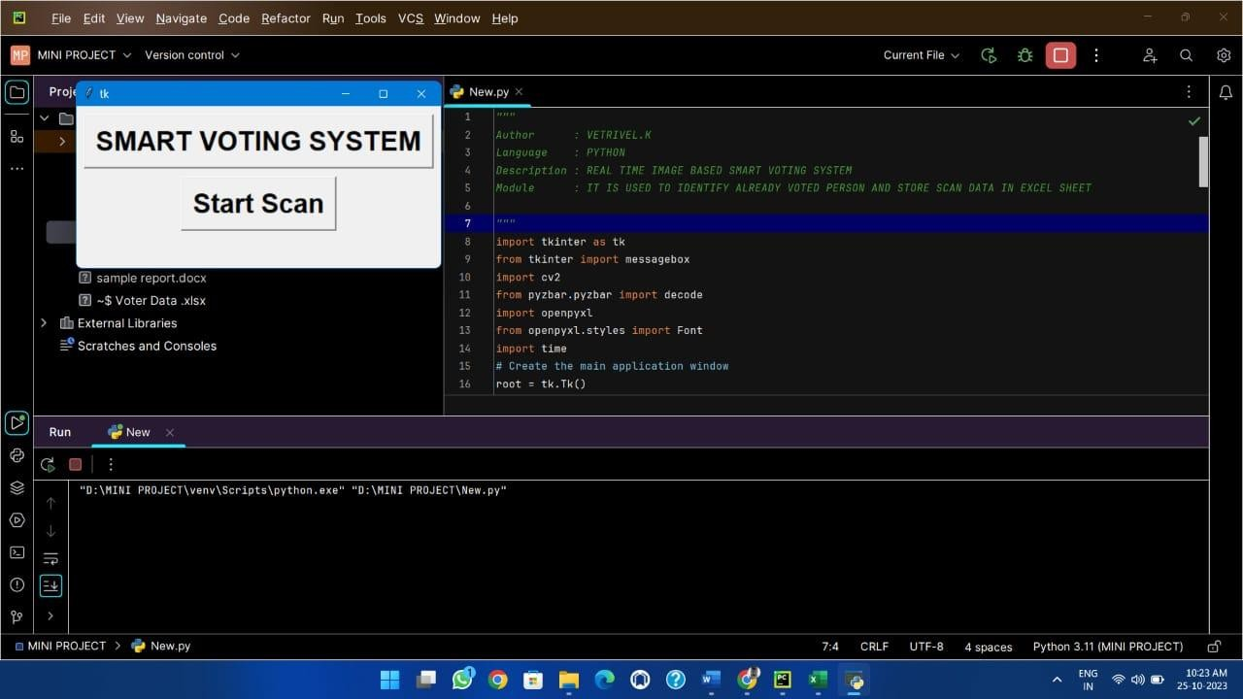

## Figure 6.1 Voter Application

In figure 6.1 process we can use a tkinter library file to display control box. The library is already available in an open source python network so, We need to download the corresponding files and check the files are working properly. Import the file into the corresponding program and use the library file in required position then run the program.

This way we can initialize the library file and work with the file in a correct manner. It is easy to access the entire python library because the

instructions are available in a open source and it is easy to implement also. Finally we can successfully run the python and display the control box on the screen.

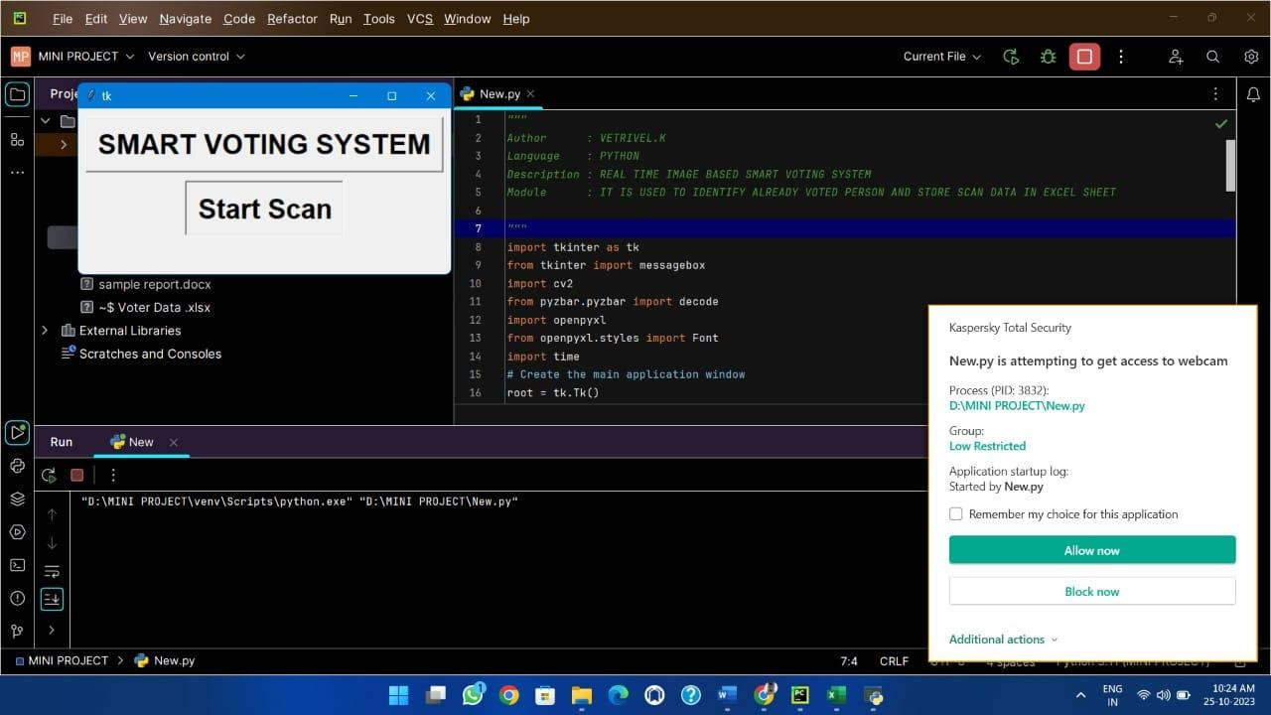

## Figure 6.2 Camera Access

In figure 6.2 shows how to enable the camera? Here the camera is enabled and controlled by CV2 library. The CV2 is a part of the python programming that is used control only the camera’s. The python has a distributed files for a every individual process so, It is a only one program language have a lot of library.

To access the camera in the cv2 library file in Python , we can use the following steps :

* + 1. Import the cv2 library
    2. Create a Video Capture object. This object will represent camera.
    3. Call the read() method on the Video Capture object . This method will return a Boolean value and a NumPy array . The Boolean value indicates whether the frame was successfully read

. The Numpy array

* + 1. contains the frame data.
    2. If the frame was successfully read , you can display it using the imshow() function.
    3. When you are finished , release the VideoCapture object by calling the release() method...

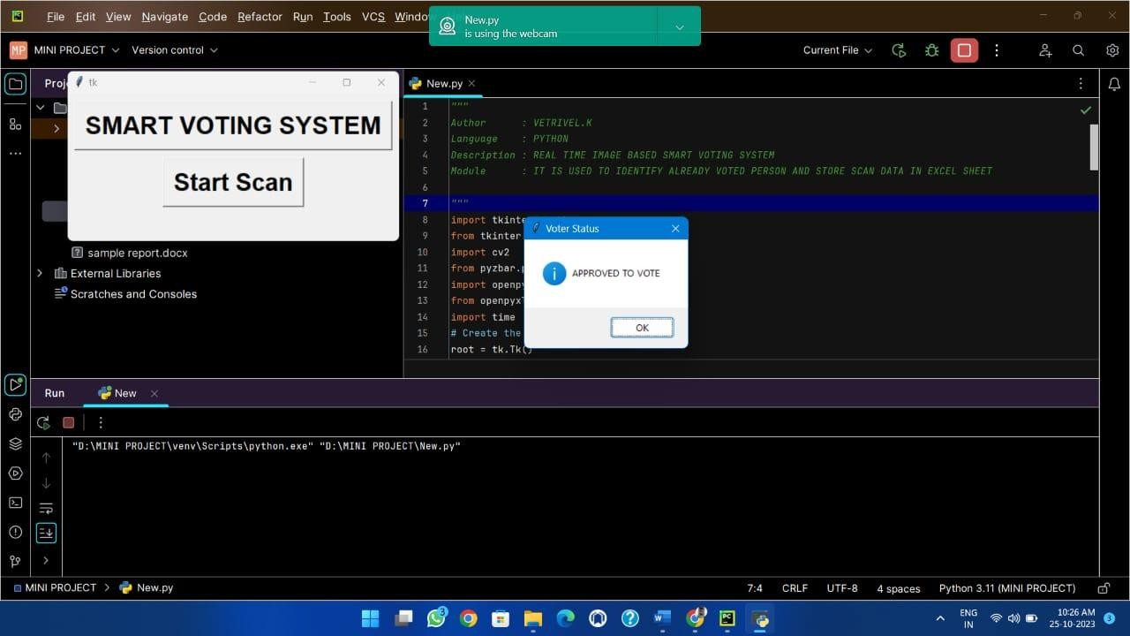

## Figure 6.3 Authenticated User

Figure 6.3 shows that the candidate can approve for her vote register in the voter poll. These requirements frequently resemble the basic tenets of conventional voting systems, which include citizenship, age, place of residence, and registration. In order to take part in such a system, people usually have to meet certain requirements, such as being residents of the jurisdiction, citizens of the applicable nation or region, and registered with the electoral authority or the smart voting system itself. They also usually need to be of a minimum age, usually 18 or older. Moreover, identification protocols are implemented to verify voters' identities and eligibility, maybe including digital identification techniques within the framework of an advanced technical smart voting system. The ability to cast a ballot in a smart voting system is contingent upon compliance with the requirements and guidelines established by the relevant regulatory authorities.

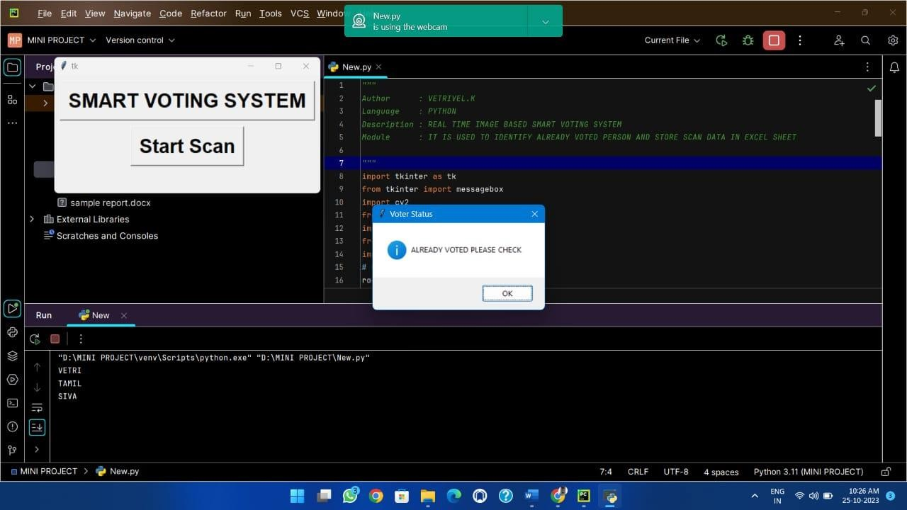

## Figure 6.4 Unauthenticated User

In figure 6.4 shows you have already cast a ballot through a smart voting system, you have done so by effectively utilizing the particular tools and techniques connected to that voting process to take part in the election. You should have gotten a confirmation email or receipt acknowledging that your vote was cast and recorded electronically. In these kinds of systems, votes are usually safely saved and can be utilized to total the votes after the election or other voting event is over. Smart voting systems frequently seek to boost voting's accuracy and efficiency, offering advantages like speedier results, fewer mistakes, and greater accessibility for voters.It is essential to get in touch with the appropriate election authorities or system administrators if you have any questions or issues concerning your vote or the smart voting system in which you took part.

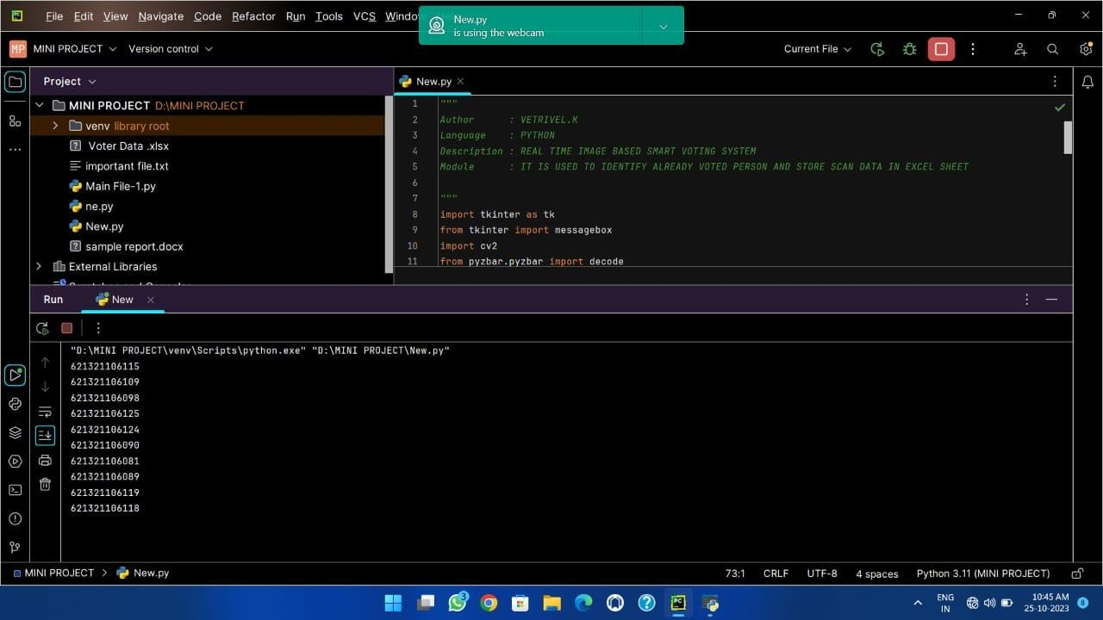

## Figure 6.5 Voted Members List

Figure 6.5 shows that the system correctly and securely records each vote when voters cast their ballots online. Following tabulation, the results are shown in real time on monitors that are available to election officials, observers, and occasionally the general public. This vote total display serves a number of crucial functions. Transparency is a priority for smart voting systems, which make votes visible to candidates, election observers, and the general public. The real-time presentation of vote counts reduces the possibility of fraud or manipulation, which fosters faith in the election's fairness.Election results are released more quickly when vote tallies are displayed instantly. This is especially helpful in situations where it's critical to publish results quickly, like in high-stakes elections or when prompt judgments are needed. Early identification of any anomalies or disparities is made possible by the real-time tracking of vote tallying.



## Figure 6.6 Voters list saved in Work sheet

In figure 6.6 shows that the excel sheet voter lists are frequently used to manage and arrange voter data for a variety of elections and voting procedures. These lists offer a methodical and user-friendly way to maintain track of qualified voters and their information. In an Excel spread sheet, typically each row represents a single voter, and the columns include details about each voter. The spread sheet features in Excel make it simple to manipulate, filter, and sort data. Because of its adaptability, election authorities can use it to update and manage voter lists and perform data analysis, which includes spotting patterns in voter demographics or participation rates.

Crucially, keeping voter lists up-to-date in Excel helps expedite Election Day check-in procedures, enabling poll workers to promptly confirm voters' names and registration status. In order to maintain the integrity of the voting process, it also helps in locating and correcting any disparities or errors in voter data.

To summarize, voter lists stored in Excel sheets are an invaluable tool for voter data management and organization, election integrity and accuracy assurance, and voting process simplification. Election officials now have a complete tool for effectively managing, updating, and analyzing voter data thanks to these computerized records.

## CHAPTER 7 ADVANTAGES AND APPLICATIONS

* 1. **ADVANTAGES**

## Enhanced Security:

Utilizes biometric data (facial recognition, fingerprints) for voter identification, reducing chances of fraudulent voting.

## Efficiency:

Speeds up the voting process, potentially reducing long queues at polling stations.

## Accessibility:

Allows remote or online voting, enabling more people, including those with disabilities or living in remote areas, to participate.

## Accuracy:

Reduces errors in vote counting as the system can automatically tally votes without human intervention.

## APPLICATIONS

* + 1. **Remote Voting**:

Allowing citizens to cast their votes from remote locations via secure online platforms, enhancing accessibility, and reducing physical presence at polling stations.

## Biometric Identification:

Utilizing facial recognition or fingerprint scanning for voter authentication, ensuring the legitimacy of the voters.

## Real-Time Vote Counting:

Using image processing algorithms to instantly count and compile votes, reducing manual labor and potentially minimizing errors in the tally.

## Enhanced Security Measures:

Implementing robust encryption and security protocols to protect voter data and ensure the integrity of the electoral process.

## CHAPTER 8 CONCLUSION

In conclusion, the real-time image-based smart voting system represents a promising and transformative approach to modernizing the electoral process. By incorporating biometric authentication, real-time image capture, and digital technology, this system aims to enhance security, accessibility, transparency, and efficiency in elections. It provides a means to address many of the challenges associated with traditional paper-based voting methods. The real-time image-based smart voting system reflects a broader trend in using technology to strengthen democratic processes, but its effectiveness ultimately depends on thorough design, rigorous testing, and ongoing maintenance to ensure its reliability, security, and fairness in facilitating free and fair elections.

## APPENDIX

import tkinter as tk

from tkinter import messagebox import cv2

from pyzbar.pyzbar import decode import openpyxl

import time

# Create the main application window root = tk.Tk() root.geometry("450x200")

# Create an Excel workbook and sheet to store barcode data wb = openpyxl.Workbook()

sheet = wb.active

sheet.title = "Barcode Data" sheet['A1'] = "Barcode Data"

# Function to start reading barcodes and store in Excel def bar ():

cap = cv2.VideoCapture(0)

used_codes = []

workbook = openpyxl.Workbook() workspace = workbook.active while True:

success, frame = cap.read() for code in decode(frame):

if code.data.decode('utf-8') not in used_codes: messagebox.showinfo("Barcode Data", f"APPROVED TO VOTE") print(code.data.decode('utf-8')) used_codes.append(code.data.decode('utf-8'))

time.sleep(2) workspace.append([code.data.decode('utf-8')])

elif code.data.decode('utf-8') in used_codes:

messagebox.showinfo("Barcode Data", f"ALREADY VOTED PLEASE CHECK")

time.sleep(2) else:

pass

workbook.save("barcode data .xlsx")

# create title for project

scan_button = tk.Button(root, text="SMART VOTING SYSTEM", font="arial 25 bold")

scan_button.pack(pady=10)

# Create a button to start scanning and store in Excel

scan_button = tk.Button(root, text="Start Scan", font="arial 25 bold", command=bar)

scan_button.pack() root.mainloop()

## REFERENCES

1. Alrebdi, Norah, Alabdulatif, Abdulatif, Iwendi, Celestine, Lian, and Zhuotao, (2022). ‘Svbe:searchable and verifiable blockchain-based electronic medical records system’, Scientific Reports, Vol.12, Issue.1, pp.1–11.
2. Alvi, Syada Tasmia, Uddin, Mohammed Nasir, Islam and Linta, (2020) ‘Digital voting: Ablockchain-based e-voting system using biohash and smart contract’, third International Conference on Smart Systems and Inventive Technology (ICSSIT), pp.228–233.
3. Alvi, Syada Tasmia, Islam, Linta, Rashme, Tamanna Yesmin, Uddin, and Mohammed Nasir (2021) ‘Bsevoting: A conceptual framework to develop electronic votingsystem using sidechain’ International Conference on Electrical Engineering, Computer Science and Informatics (EECSI), pp.10–15.
4. Baujard, Antoinette, Gavrel, Fr´ed´eric, Igersheim, Herrade, Laslier, Jean-François, Lebon and Isabelle(2014), “Who’s favored by evaluative voting?“ An experiment conducted during the 2012 French presidential election. Elect. pp. 131–145.
5. Ben Ayed and Ahmed (2017) ‘A conceptual secure blockchain based electronic voting system’, International Journal of Network Security & Its Applications, pp. 01–09.
6. Dimitriou Tassos (2020) ‘Efficient, coercion-free and universally verifiable blockchain-based voting’, Computer Networks. pp 74-83
7. Forsythe, Robert, Myerson, Roger B., Rietz, Thomas A., Weber and Robert J (1993) “An experiment on coordination in multi-candidate elections”, the importance of polls and election histories. pp. 233–247
8. Gautam, Mehul, Akthar, Shoaib, Basha, Aktar, Dilip and Golda, (2021) ‘Blockchain for secure and proper management of medical data and records’ International Conference on Electronics, Communication and Aerospace Technology (ICECA), pp.671–678.
9. Ghavamipoor, Hoda, Shahpasand and Maryam (2013) ‘An anonymous and efficient evoting scheme’, international Conference on e- Commerce in Developing Countries:with focus on e-Security, pp. 1–13.
10. Hardwick, Freya Sheer, Gioulis, Apostolos, Akram, Raja Naeem, Markantonakis and Konstantinos (2018) ‘E-voting with blockchain: An e-voting protocol with decentralisation and voter privacy’ in IEEE International Conference on Internet of Things (iThings) and IEEE Green Computing and Communications (GreenCom) and IEEE Cyber, Physical and Social Computing (CPSCom) and IEEE Smart Data (SmartData), IEEE, pp. 1561–1567.
11. Hengavalli, Pranith, Manoj, Prashanth, Thomas, Likewin and Srinivasa Murthy (2019) ‘End-to-end verifiable electronic voting system using delegated proof of stake on blockchain’ SSRN Electronic Journal, Vol.1, pp. 23-28
12. Jafar, Uzma, Aziz, Mohd Juzaiddin Ab, Shukur and Zarina (2021). ‘Blockchain for electronic voting system–review and open research challenges’ Sensors, Vol.21, Issue.17, pp. 58-74.
13. Madhuri, B., Adarsha, M.G., Pradhyumna, K.R and Prajwal, B.M

(2017) ‘Secured smar voting system using aadhar’ International Conference On Emerging Computation and Information Technologies.

1. Mykletun, Einar, Narasimha, Maithili, Tsudik and Gene (2003). ‘Providing authentication and integrity in outsourced databases using merkle hash trees’, UCI-SCONCE Technical Report. Pp.112-120.
2. Sun, Xin, Wang, Quanlong, Kulicki, Piotr, Sopek, Mirek, (2018). A simple voting protocol on quantum blockchain. International Journal of Theoretical Physics 10. Pp.348-357.
3. Syed, Shahram Najam, Shaikh, Aamir, Naqvi and Shabbar (2018) ‘A novel hybrid biometric electronic voting system: Integrating finger print and face recognition’, Mehran University Research Journal of Engineering and Technology, Vol.no.37, Issue., Pp. 37-48.
4. Uddin, M.A., Stranieri, A., Gondal, I and Balasubramanian, V (2019). ‘A decentralized patient agent controlled blockchain for remote patient monitoring’, International Conference on Wireless and Mobile Computing, Networking and Communications (WiMob), pp. 1–8.
5. Yi Haibo (2019) ‘Securing e-voting based on blockchain in p2p network’, EURASIP Journal on Wireless Communications and Networking, Pp.1–9.
6. Zaghloul, Ehab, Li, Tongtong, Ren and Jian (2021) ‘D-bame: Distributed blockchain-based anonymous mobile electronic voting’, IEEE Internet of Things Journal.Pp.103-112.
7. Zhang, W., Yuan, Y., Hu, Y., Huang, S., Cao, S., Chopra, A and Huang, S., (2018) ‘A privacy preserving voting protocol on blockchain’, pp. 401–408.